Chapter 7, Problem 74.

Determine v_{o}(t) for t > 0 in the circuit of Fig. 7.139. Let i_{s} = 10 u(t) μA and assume that the capacitor is initially uncharged.

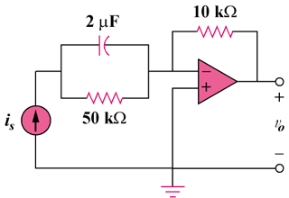

Figure 7.139
For Prob. 7.74.

